**Activity: Performing an analysis**

**Introduction**

In your Microsoft Power BI analytics journey thus far, you have learned about statistical summary, groups and bins, histograms, **Top N** analysis, and clustering. In this step-by-step exercise, you will apply some of your newly gained knowledge to enhance the three visualizations in the report, *Adventure Works Fact Sales.xlsx,* using Power BI analytics.

Your task is to:

1. Enhance the funnel chart by highlighting the top 10 selling products by sales amount.
2. Enhance the clarity of the histogram by using age bins instead of distinct ages.
3. Enhance the scatter chart by clustering the cities into four categories according to their performance.

**Instructions**

**Step 1: Download the data**

* Download and open the *Performing an analysis.pbix* file.

[Performing an analysis](https://d3c33hcgiwev3.cloudfront.net/0Ub2C0RHTr-_z9AwkNuoUg_4eaaaed28ea04874aed0d37c8bc544e1_Performing-an-analysis.pbix?Expires=1712016000&Signature=NGx3Z0gWjpcPN6hNBpxRCkdXkgIN5aIkQrLhGTZuwKOyGnQQpEqBXqY0Xgfs-4rvFS07GkPVo9JVVUS5ggIsWh-ju8T-qMVrcwujGG8okUqDqewCjySCgf18ifAmiuYIJ2mJc~Ty1t9zm89XoEEwbnUgDmqL8Sq3cZhgNxCAjpA_&Key-Pair-Id=APKAJLTNE6QMUY6HBC5A" \t "_blank)

[PBIX File](https://d3c33hcgiwev3.cloudfront.net/0Ub2C0RHTr-_z9AwkNuoUg_4eaaaed28ea04874aed0d37c8bc544e1_Performing-an-analysis.pbix?Expires=1712016000&Signature=NGx3Z0gWjpcPN6hNBpxRCkdXkgIN5aIkQrLhGTZuwKOyGnQQpEqBXqY0Xgfs-4rvFS07GkPVo9JVVUS5ggIsWh-ju8T-qMVrcwujGG8okUqDqewCjySCgf18ifAmiuYIJ2mJc~Ty1t9zm89XoEEwbnUgDmqL8Sq3cZhgNxCAjpA_&Key-Pair-Id=APKAJLTNE6QMUY6HBC5A" \t "_blank)

**Step 2: Enhance the funnel chart with Top N analysis**

The funnel chart features all 295 products and their corresponding revenue. Due to the substantial number of products, the visualization is cluttered. To address this, apply **Top N** analysis to the **funnel chart** to highlight the top 10 selling products by revenue.

1. Select the funnel chart visual. You can select the **Focus mode** button on the visual to enlarge it on your screen.

2. Navigate to the **Filter** pane, specifically focusing on the **Product** category.

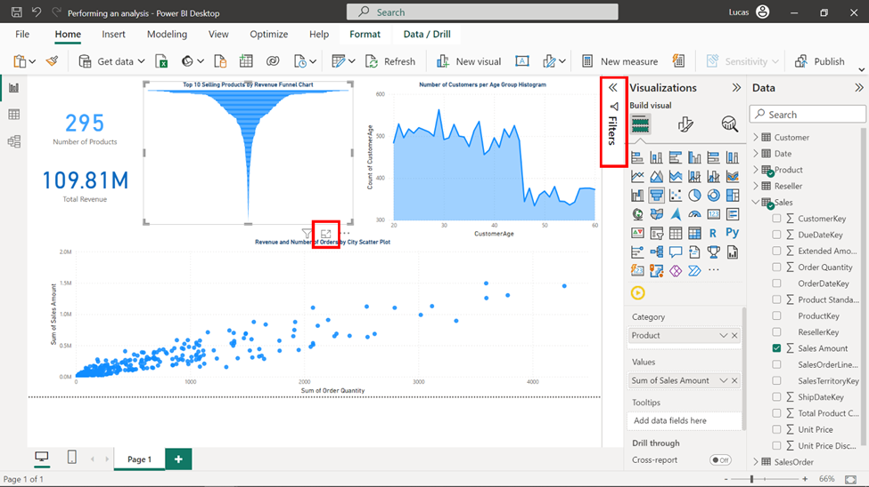

3. Select the down arrow to expand your filtering options.

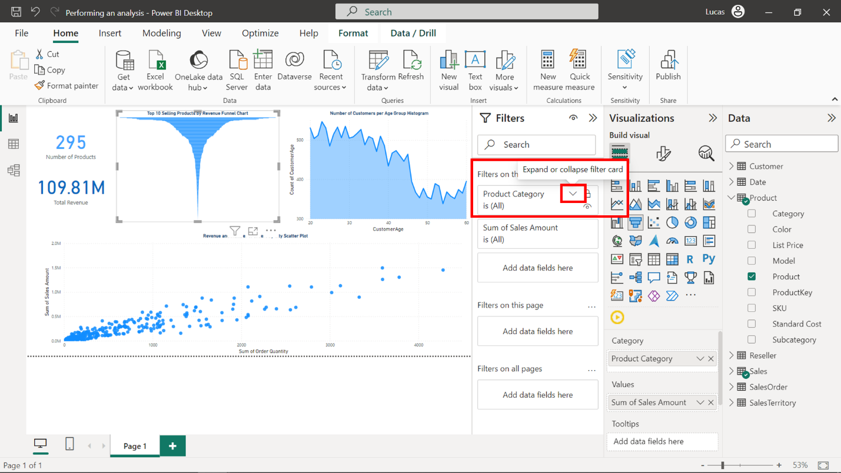

4. Select **Top N** as the **Filter type**.

5. Ensure **Top** is selected and input 10 as the **Filter value**.

6. Add **Sales Amount** to the **By value** field to enable sorting by revenue on the chart.

7. Finally, select **Apply Filter** to see the updated chart with the top 10 Selling Products by Revenue.

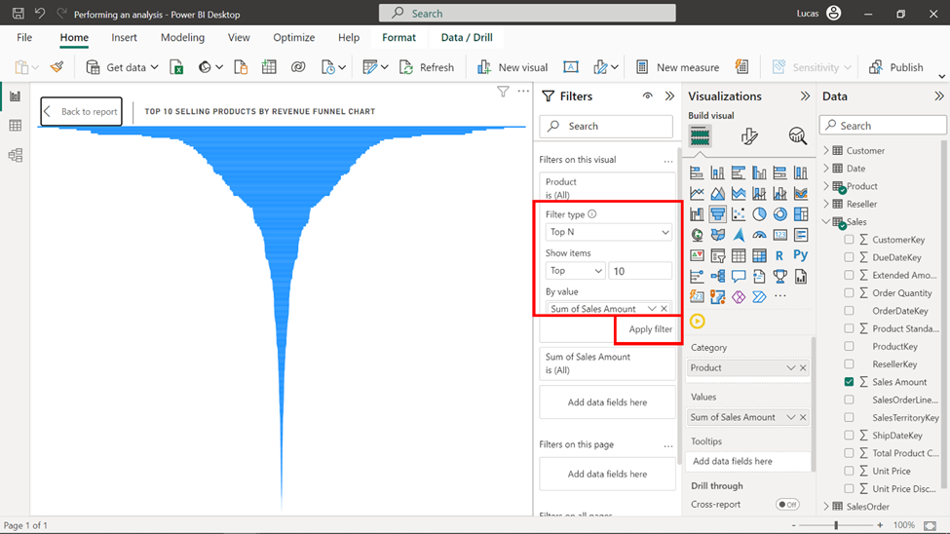

8. Your visual should now look like this:

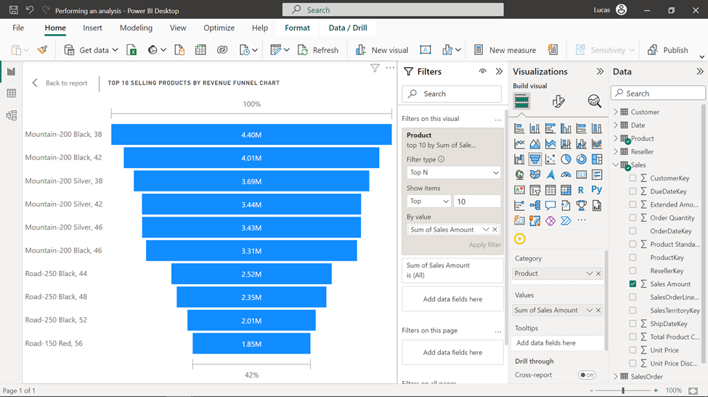

**Step 3: Enhance the histogram with age group bins**

To enhance the histogram using age group bins, follow these steps:

1. Locate the **CustomerAge** column in the **Data** pane on the right.

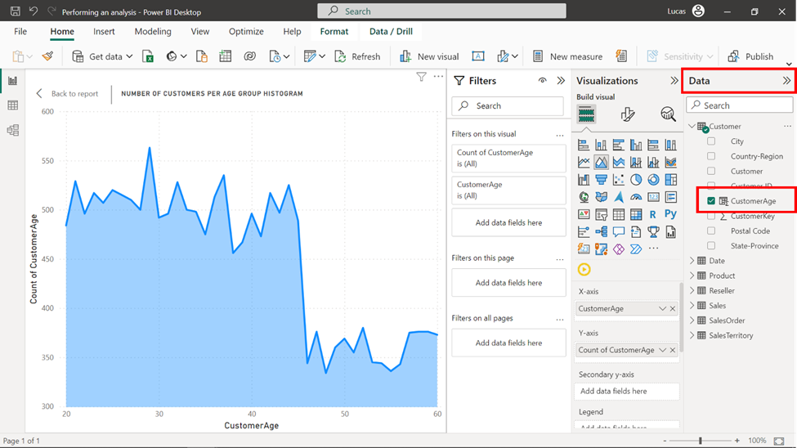

2. Right-click on **CustomerAge** and select **New group** from the pop-up menu.

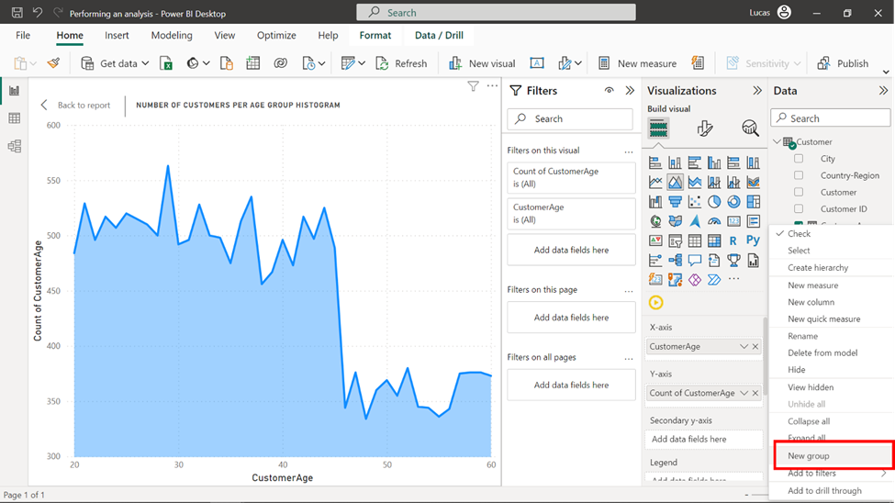

3. Select **Bin** on the **Groups** menu as the **Group type** and **Size of bins** as the **Bin type**.

4. To segment customer ages into decade ranges (20-30, 30-40, 40-50, 50-60), set the bin size as 10 and select **OK**.

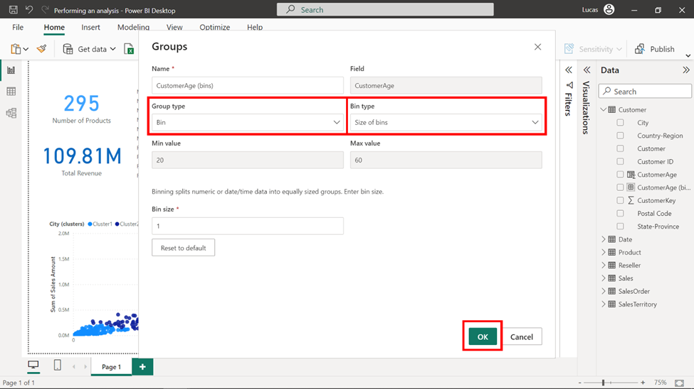

5. Remove **CustomerAge** from the **X-axis** of the histogram visualization.

6. Drag and drop the newly created **CustomerAge** bin to the **X-axis** to incorporate the age group bins.

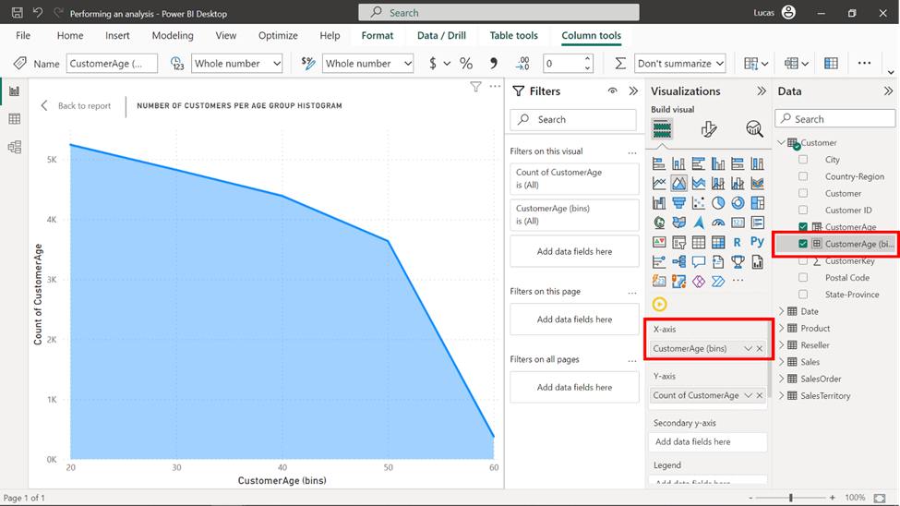

**Step 4: Add clustering techniques to the scatter chart**

To integrate the clustering technique into the scatter chart:

1. Select the **ellipsis** (three dots) located at the upper-right corner of the scatter chart.

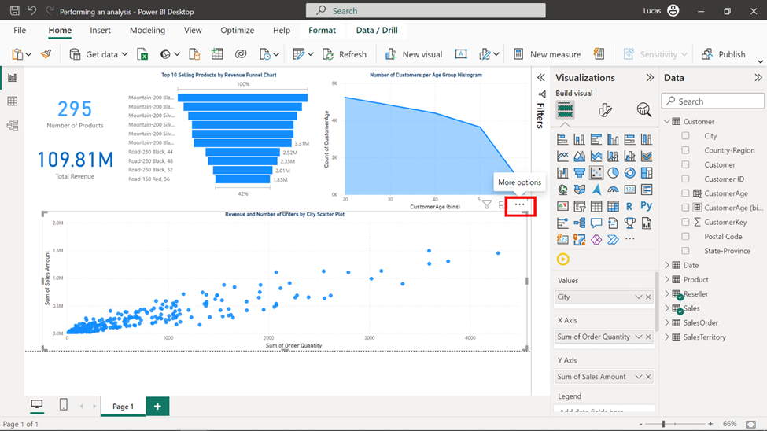

2. Select the **Automatically find clusters** option from the drop-down menu.

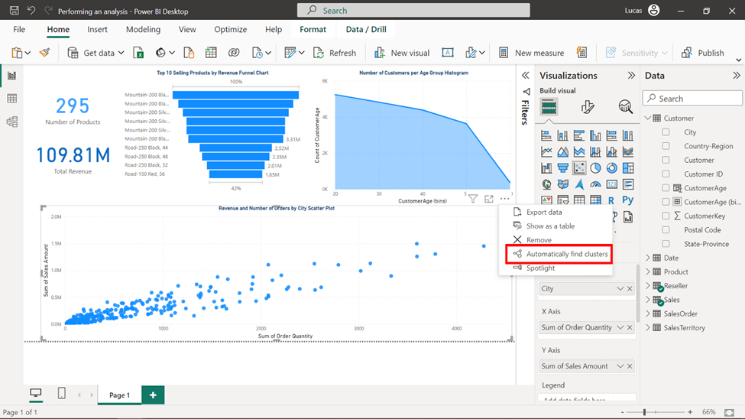

3. A **Clusters** window appears. Modify the description to **Clusters for City based on Revenue and Order Number**.

4. Input 4 as the desired number in the Number of clusters field.

5. Select **OK** to finalize the clustering settings.

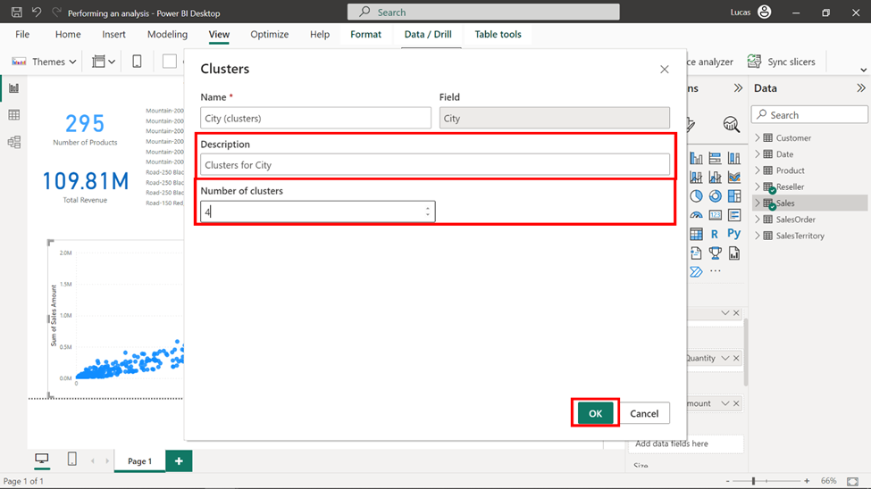

6. The final output of your report should look like this:

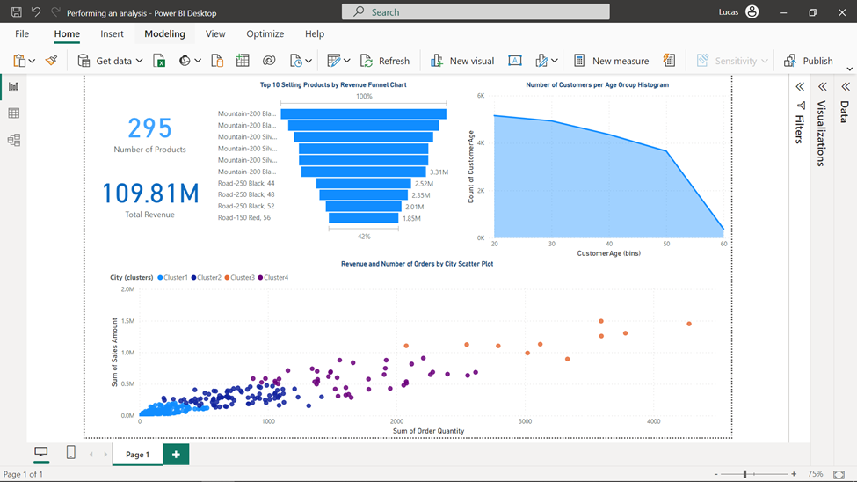

**Conclusion**

The addition of analytics to the report has significantly raised the value of the information it provides. The Top N analysis has effectively highlighted the best-performing products, offering a concise overview of their success. Additionally, the incorporation of age group binning using a histogram has visually represented the decline in customer numbers per age group.